Thomas Bullock Church of England
Primary Academy

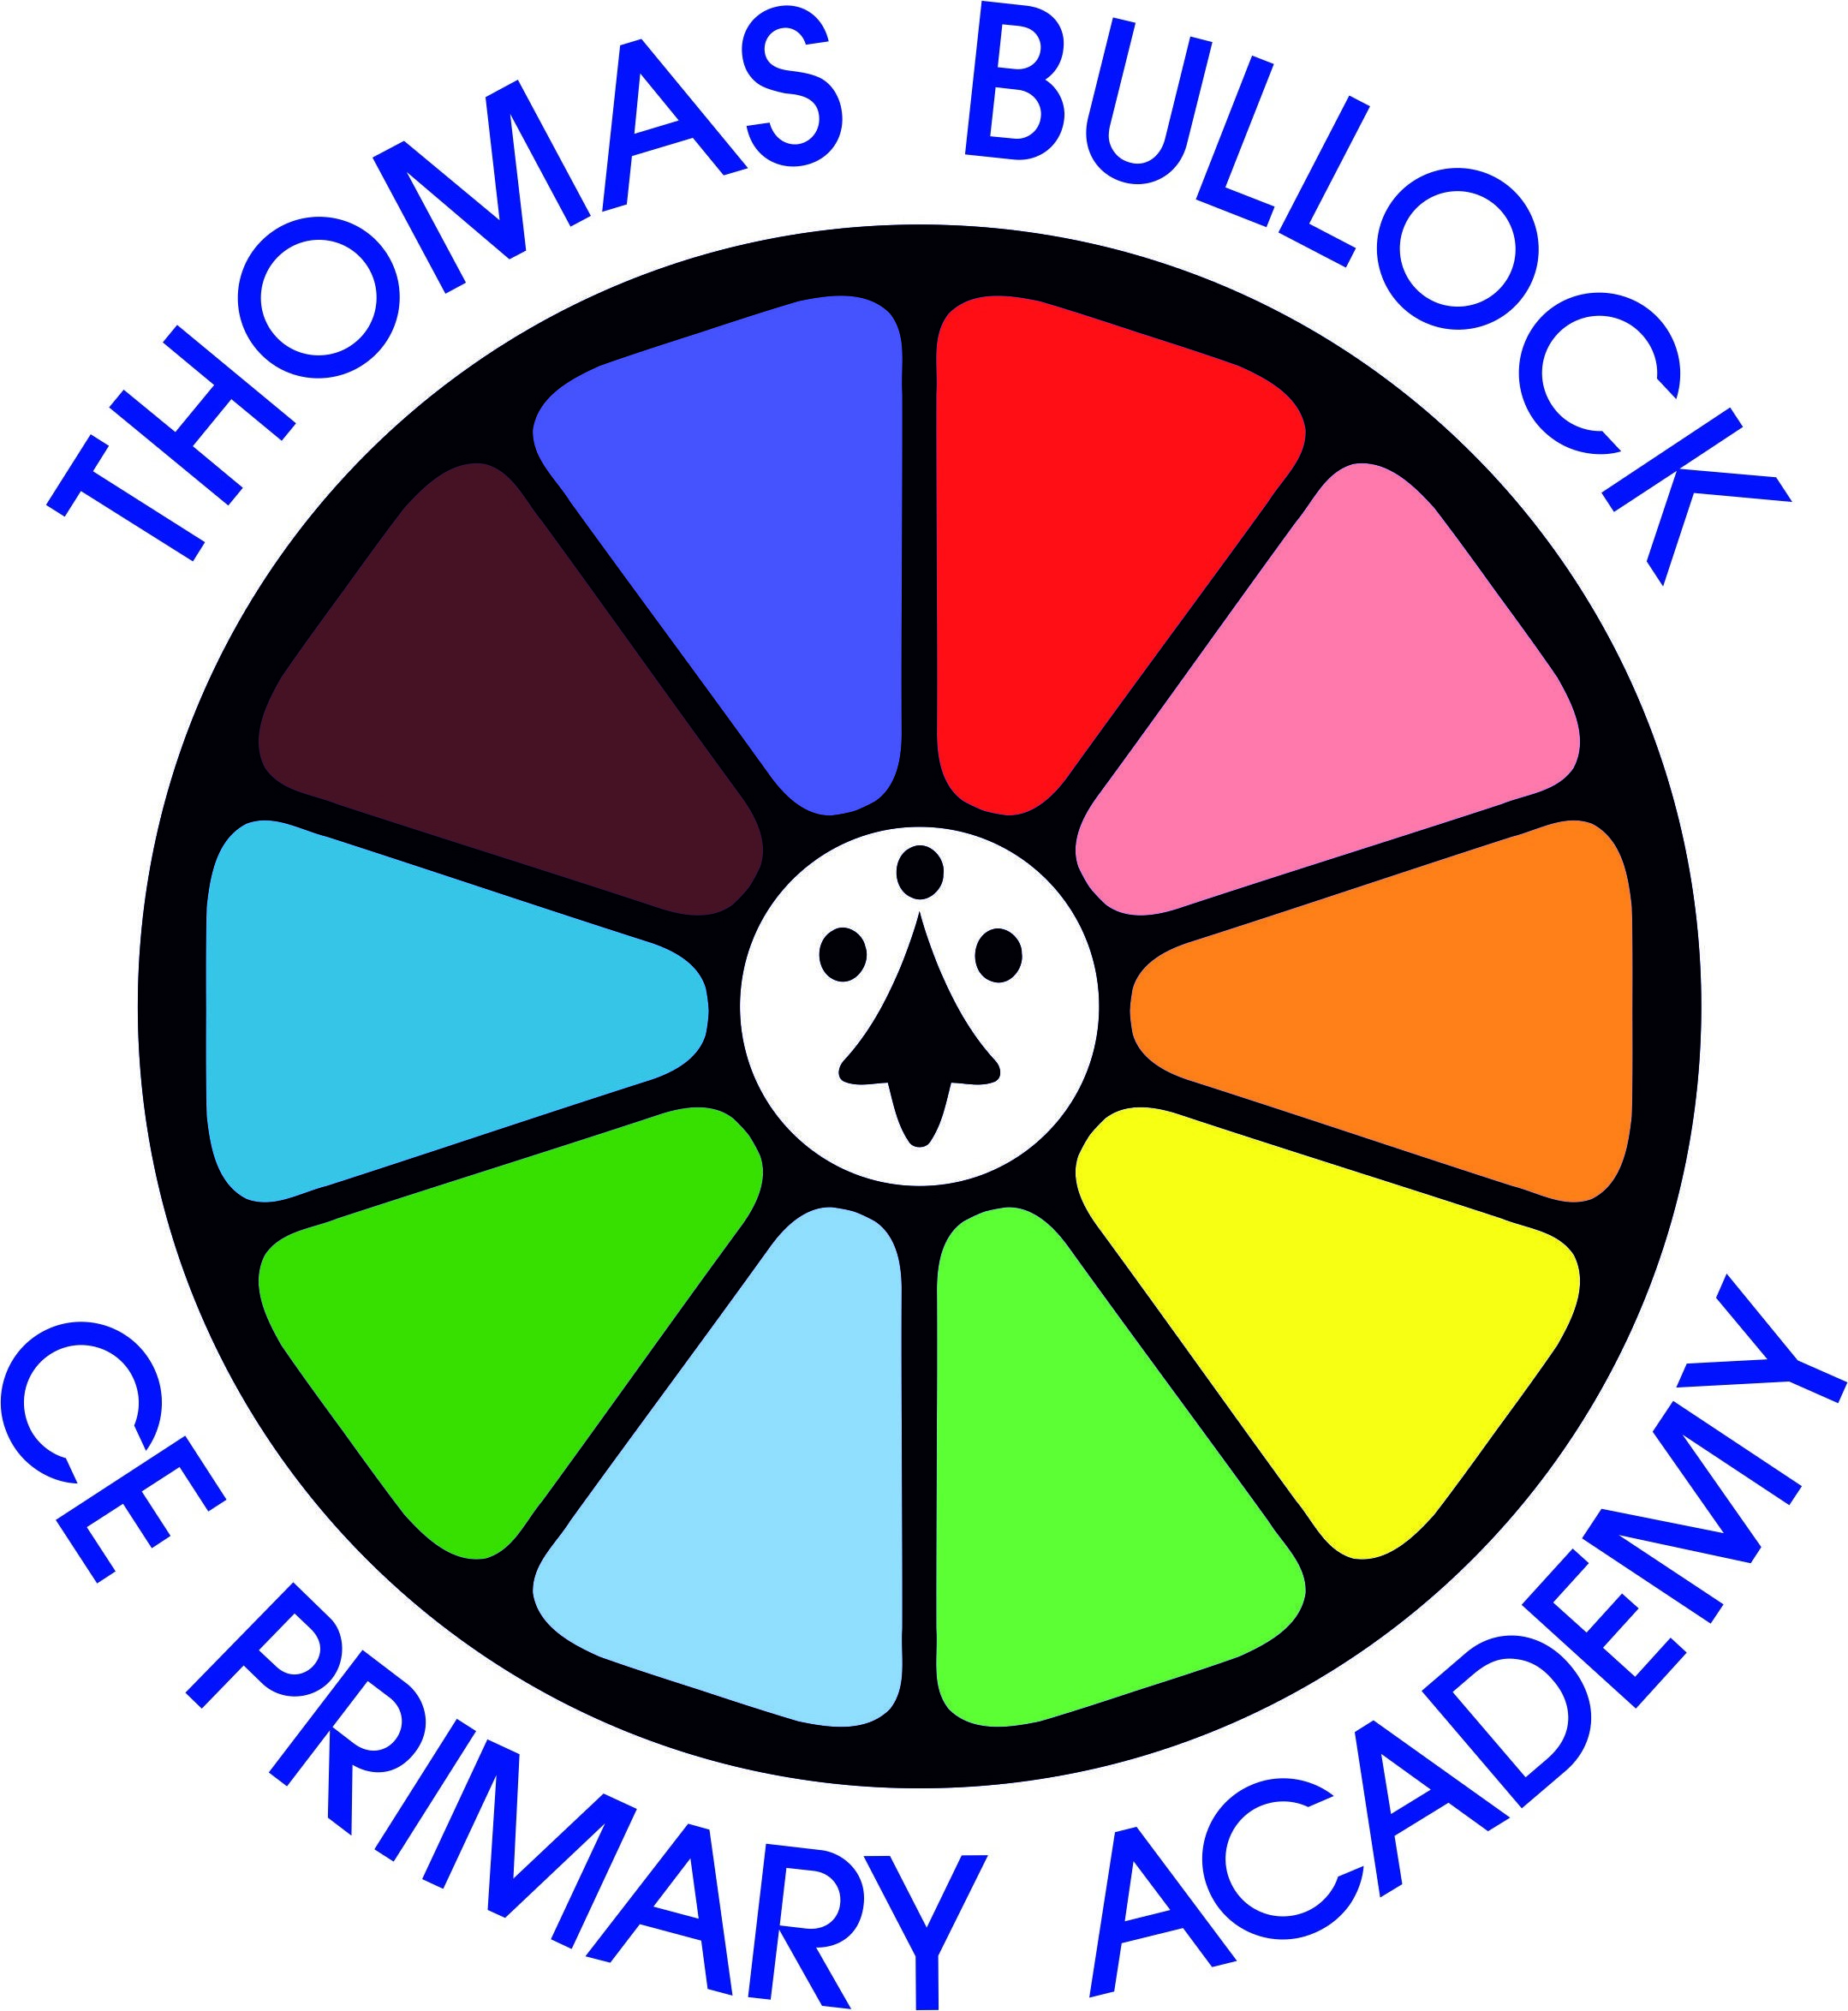

Physical Education Curriculum

Physical Education
Physical Education Units by Key Stage and Year Group
Key Stage One
Year 1 |  |  |  |  |  |  |  |  |  |  | Year 2
Real P.E
Tag Rugby | Gymnastics |  | Dance |  |  | Tri Golf |  |  | Athletics |  | Tag Rugby |  | Gymnastics |  | Dance | Tri Golf |  | Athletics
Lower Key Stage Two
Year 3 |  |  |  |  |  |  |  |  |  |  | Year 4
Real P.E
Tag Rugby | Gymnastics | Dance |  | Tennis |  |  | Swimming |  |  | Athletics | Tag Rugby | Gymnastics |  | Dance |  | Tennis | Athletics
Upper Key Stage Two
Year 5 |  |  |  |  |  |  |  |  |  |  | Year 6
Real P.E
Tag Rugby | Gymnastics | Dance |  |  | Cricket |  |  | Athletics |  |  | Tag Rugby | Gymnastics |  | Dance |  | Cricket | Athletics

Physical Education
Early Years Foundation Stage
Real P.E  During Year R, pupils should be taught to use the following fundamental movement skills  - Floor Movement Patterns  - Static Balances - one leg standing  - Dynamic Balance to Agility  - Static Balance seated  - Dynamic balance  - Static Balance – small base  - Balls skills  - Balance in pairs  - Coordination with equipment  - Agility – reaction/response  - Agility ball – chasing  - Static balance – floor work |  | During Year R, pupils should be taught the following using Multi-ability Cog Focus and Learning Journeys  Personal:  - follow instructions, practise safely and work on simple tasks by myself (Level 1)  - enjoy working on simple tasks with help (Pre-level 1)  Social:  - work sensibly with others, taking turns and sharing (Level 1)  - play with others and take turns and share with help (Pre-level 1)  Cognitive:  - understand and follow simple rules and can name some things I am good at (Level 1)  - follow simple instructions (Pre-level 1)  Creative:  - explore and describe different movements (Level 1)  - observe and copy others (Pre-level 1)  Physical:  - perform a single skill or movement with some control. I can perform a small range or skills and link two movements together (Level 1)  - move confidently in different ways (Pre-level 1)  Health and Fitness:  - aware of why exercise is important for good health (Level 1)  - aware of the changes to the way I feel when I exercise (Pre-level 1)
Year R Program of Study
EYFS Physical Development Learning Goals
Moving and Handling
Early Learning Goal - Children show good control and co-ordination in large and small movements. They move confidently in a range of ways, safely negotiating space. They handle equipment and tools effectively, including pencils for writing.
Health and Self-Care
Early Learning Goal - Children know the importance for good health of physical exercise, and a healthy diet, and talk about ways to keep healthy and safe. They manage their own basic hygiene and personal needs successfully, including dressing and going to the toilet independently.

Me and Myself | Ball Skills |  | Working with Others
Learning Objectives  - Dresses with help.  - Aware of the boundaries set, and of behavioural expectations in the setting.  - Moves freely and with pleasure and confidence in a range of ways, such as slithering, shuffling, rolling, crawling, walking, running, jumping, skipping, sliding and hopping.  - Explains own knowledge and understanding, and asks appropriate questions of others.  - Shows understanding of prepositions such as ‘under’, ‘on top’, ‘behind’ by carrying out an action.  - Keeps play going by responding to what others are saying or doing.  - Listens and responds to ideas expressed by others in conversation or discussion. | Learning Objectives  - Handles tools, objects, construction and malleable materials safely and with increasing control.  - Understands that equipment and tools have to be used safely.  - Shows increasing control over an object in pushing, patting, throwing, catching or kicking it.  - Observes the effects of activity on their bodies.  - Can catch a large ball.  - Can play in a group, extending and elaborating play ideas.  - Begin to accept the needs of others and can take turns and share resources, sometimes with support from others.  - Negotiates space successfully when playing racing and chasing games with other children, adjusting speed or changing direction to avoid obstacles.  - Realises not only objects, but anything can be counted, including steps, claps or jumps. |  | Learning Objectives  - Can play in a group.  - Negotiates space successfully when playing racing and chasing games with other children, adjusting speed or changing direction to avoid obstacles.  - Begin to accept the needs of others and can take turns and share resources, sometimes with support from others.  - Shows some understanding that good practices with regard to exercise, eating, sleeping and hygiene can contribute to good health.  - Aware of the boundaries set, and of behavioural expectations in the setting.  - Runs skilfully and negotiates space successfully, adjusting speed or direction to avoid obstacles.  - Keeps play going by responding to what others are saying or doing.  - Links Sounds to letters, naming and sounding the letters of the alphabet.  - Respond to simple instructions.

Year R Program of Study
Throwing and Catching | Fun and Games | Movement Development
Learning Objectives  - Shows increasing control over an object in pushing, patting, throwing, catching or kicking it.  - Understands that equipment and tools have to be used safely.  - Can catch.  - Respond to simple instructions.  - Shows increasing control over an object when throwing it.  - Can catch a ball.  - Moves freely and with pleasure and confidence in a range of ways, such as slithering, shuffling, rolling, crawling, walking, running, jumping, skipping, sliding and hopping.  - Can play in a group.  - Begin to accept the needs of others and can take turns and share resources, sometimes with support from others. | Learning Objectives  - Runs skilfully and negotiates space successfully, adjusting speed or direction to avoid obstacles  - Shows understanding of the need for safety when tackling new challenges, and considers and manages some risks.  - Plays alongside other children who are engaged in the same theme.  - Two channelled attention – can listen and do for a short span.  - Respond to simple instructions.  - Shows increasing control over an object in pushing, patting, throwing, catching or kicking it.  - Can describe self in positive terms and talk about abilities.  - Understands that equipment and tools have to be used safely.  - Moves freely and with pleasure and confidence in a range of ways, such as slithering, shuffling, rolling, crawling, walking, running, jumping, skipping, sliding and hopping.  - Observes the effects of activity on their bodies.  - Begin to accept the needs of others and can take turns and share resources, sometimes with support from others.  - Counts objects to 10, and beginning to count beyond 10. | Learning Objectives  - Travels with confidence and skill around, under, over and through balancing and climbing equipment.  - Shows understanding of the need for safety when tackling new challenges, and considers and manages some risks.  - Practices some appropriate safety measures without direct supervision.  - Moves freely and with pleasure and confidence in a range of ways, such as slithering, shuffling, rolling, crawling, walking, running, jumping, skipping, sliding and hopping.  - Negotiates space successfully when playing racing and chasing games with other children, adjusting speed or changing direction to avoid obstacles.  - Runs skilfully and negotiates space successfully, adjusting speed or direction to avoid obstacles.  - Observes the effects of activity on their bodies.

Physical Education
Key Stage One
Real P.E  During Year 1, pupils should be taught to use the following fundamental movement skills  - Co-ordination – Floor Movement Patterns  - Static Balance – One Leg Standing  - Dynamic Balance to Agility  - Static Balance – Seated  - Dynamic Balance  - Static Balance – Small Base  - Co-Ordination – Ball Skills  - Counter Balance in Pairs  - Co-ordination with Equipment  - Agility – Reaction/Response  - Agility – Ball Chasing  - Station Balance – Floor Work |  |  | During Year 1, pupils should be taught the following using Multi-ability Cog Focus and Learning Journeys  Personal:  - several times if at first I don’t succeed and I ask for help when appropriate (Level 2)  - follow instructions, practise safely and work on simple tasks by myself (Level 1)  Social:  - help praise and encourage others in their learning (Level 2)  - work sensibly with others, taking turns and sharing (Level 1)  Cognitive:  - begin to order instructions, movements and skills. With help I can recognise similarities and differences in performance and I can explain why someone is working or performing well (Level 2)  - understand and follow simple rules and can name some things I am good at (Level 1)  Creative:  - begin to compare my movements and skills with those of others. I can select and link movements together to fit a theme (Level 2)  - explore and describe different movements (Level 1)  Physical:  - perform a range of skills with some control and consistency. I can perform a sequence of movements with some changes in level, direction and speed (Level 2)  - perform a single skill or movement with some control. I can perform a small range or skills and link two movements together (Level 1)  Health and Fitness:  - say how my body feels before, during and after exercise. I use equipment appropriately and move and land safely (Level 2)  - aware of why exercise is important for good health (Level 1)
Year One Program of Study
Pupils should develop fundamental movement skills, become increasingly competent and confident and access a broad range of opportunities to extend their agility, balance and coordination, individually and with others. They should be able to engage in competitive (both against self and against others) and co-operative physical activities, in a range of increasingly challenging situations.
Pupils should be taught to:
- master basic movements including running, jumping, throwing and catching, as well as developing balance, agility and co-ordination, and begin to apply these in a range of activities
- participate in team games, developing simple tactics for attacking and defending
- perform dances using simple movement patterns

Tag Rugby | Gymnastics | Dance | Tri Golf | Athletics

Physical Education
Key Stage One
Real P.E  During Year 2, pupils should be taught to use the following fundamental movement skills  - Coordination – Floor Movement Patterns  - Static Balance – One Leg Standing  - Dynamic Balance to Agility  - Static Balance – Seated  - Dynamic Balance  - Static Balance – Small Base  - Coordination – Ball Skills  - Counter Balance in Pairs  - Coordination with Equipment  - Agility – Reaction/Response  - Agility – Ball Chasing  - Static Balance – Floor Work |  |  | During Year 2, pupils should be taught the following using Multi-ability Cog Focus and Learning Journeys  Personal:  - know where I am with my learning and I have begun to challenge myself (Level 3)  - Plus Level 1 and 2 see Yr 1  Social:  - show patience and support others, listening well to them about our work. I am happy to show and tell them about my ideas (Level 3)  - Plus Level 1 and 2 see Yr 1  Cognitive:  - understand the simple tactics of attacking and defending. I can explain what I am doing well and I have begun to identify areas for improvement (Level 3)  - Plus Level 1 and 2 see Yr 1  Creative:  - make up my own rules and versions of activities. I can respond  differently to a variety of tasks or music and I can recognise similarities and differences in movements and expression (Level 3)  - Plus Level 1 and 2 see Yr 1  Physical:  - perform and repeat longer sequences with clear shapes and controlled movement. I can select and apply a range of skills with good control and consistency (Level 3)  - Plus Level 1 and 2 see Yr 1  Health and Fitness:  - describe how and why my body feels during and after exercise. I can explain why we need to warm up and cool down (Level 3)  - Plus Level 1 and 2 see Yr
Year Two Program of Study
Pupils should develop fundamental movement skills, become increasingly competent and confident and access a broad range of opportunities to extend their agility, balance and coordination, individually and with others. They should be able to engage in competitive (both against self and against others) and co-operative physical activities, in a range of increasingly challenging situations.
Pupils should be taught to:
- master basic movements including running, jumping, throwing and catching, as well as developing balance, agility and co-ordination, and begin to apply these in a range of activities
- participate in team games, developing simple tactics for attacking and defending
- perform dances using simple movement patterns

Tag Rugby | Gymnastics | Dance | Tri Golf | Athletics

Physical Education
Lower Key Stage Two
Real P.E  During Year 3, pupils should be taught to use the following fundamental movement skills  - Coordination – Floor Movement Patterns  - Static Balance – One Leg Standing  - Dynamic Balance to Agility  - Static Balance – Seated  - Dynamic Balance  - Coordination – Ball Skills  - Coordination with Equipment  - Counter Balance in pairs  - Agility – Reaction/Response  - Static Balance – Floor Work  - Agility Ball Chasing  - Static Balance – Small Base |  |  | During Year 3, pupils should be taught the following using Multi-ability Cog Focus and Learning Journeys  Personal:  - cope well and react positively when things become difficult. I can persevere with a task and I can improve my performance through regular practice (Level 4)  - Plus Level 1 and 2 see Yr 1, Level 3 see Yr 2  Social:  - cooperate well with others and give helpful feedback. I help organise roles and responsibilities and I can guide a small group through a task (Level 4)  - Plus Level 1 and 2 see Yr 1, Level 3 see Yr 2  Cognitive:  - understand ways (criteria) to judge performance and I can identify specific parts to continue to work upon. I can use my awareness of space and others to make good decisions (Level 4)  - Plus Level 1 and 2 see Yr 1, Level 3 see Yr 2  Creative:  - link actions and develop sequences of movements that express my own ideas. I can change tactics, rules or tasks to make activities more fun or challenging (Level 4)  - Plus Level 1 and 2 see Yr 1, Level 3 see Yr 2  Physical:  - perform a variety of movements and skills with good body tension. I can link actions together so that they flow in running, jumping and throwing activities (Level 4)  - Plus Level 1 and 2 see Yr 1, Level 3 see Yr 2  Health and Fitness:  - I can describe the basic fitness components and explain how often and how long I should exercise to be healthy. I can record and monitor how hard I am working (Level 4)  - Plus Level 1 and 2 see Yr 1, Level 3 see Yr 2
Year Three Program of Study
Pupils should continue to apply and develop a broader range of skills, learning how to use them in different ways and to link them to make actions and sequences of movement. They should enjoy communicating, collaborating and competing with each other. They should develop an understanding of how to improve in different physical activities and sports and learn how to evaluate and recognise their own success.
Pupils should be taught to:
- use running, jumping, throwing and catching in isolation and in combination
- play competitive games, modified where appropriate [for example, badminton, basketball, cricket, football, hockey, netball, rounders and tennis], and apply basic principles suitable for attacking and defending
- develop flexibility, strength, technique, control and balance [for example, through athletics and gymnastics]
- perform dances using a range of movement patterns
- take part in outdoor and adventurous activity challenges both individually and within a team
- compare their performances with previous ones and demonstrate improvement to achieve their personal best

Swimming and water safety
Schools must provide swimming instruction either in key stage 1 or key stage 2.
In particular, pupils should be taught to:
- swim competently, confidently and proficiently over a distance of at least 25 metres
- use a range of strokes effectively [for example, front crawl, backstroke and breaststroke]
- perform safe self-rescue in different water-based situations

Tag Rugby | Gymnastics | Dance | Swimming | Tennis | Athletics

Physical Education
Lower Key Stage Two
Real P.E  During Year 4, pupils should be taught to use the following fundamental movement skills  - Coordination – Floor Movement Patterns  - Static Balance – One Leg Standing  - Dynamic Balance to Agility  - Static Balance – Seated  - Dynamic Balance  - Coordination – Ball Skills  - Coordination with Equipment  - Counter Balance in pairs  - Agility – Reaction/Response  - Static Balance – Floor Work  - Agility Ball Chasing  - Static Balance – Small Base |  |  | During Year 4, pupils should be taught the following using Multi-ability Cog Focus and Learning Journeys  Personal:  - I cope well and react positively when things become difficult. I can persevere with a task and I can improve my performance through regular practice (Level 4)  - Plus Level 1 and 2 see Yr 1, Level 3 see Yr 2  Social:  - I cooperate well with others and give helpful feedback. I help organise roles and responsibilities and I can guide a small group through a task (Level 4)  - Plus Level 1 and 2 see Yr 1, Level 3 see Yr 2  Cognitive:  - I can understand ways (criteria) to judge performance and I can identify specific parts to continue to work upon. I can use my awareness of space and others to make good decisions (Level 4)  - Plus Level 1 and 2 see Yr 1, Level 3 see Yr 2  Creative:  - I can link actions and develop sequences of movements that express my own ideas. I can change tactics, rules or tasks to make activities more fun or challenging (Level 4)  - Plus Level 1 and 2 see Yr 1, Level 3 see Yr 2  Physical:  - I can perform a variety of movements and skills with good body tension. I can link actions together so that they flow in running, jumping and throwing activities (Level 4)  - Plus Level 1 and 2 see Yr 1, Level 3 see Yr 2  Health and Fitness:  - I can describe the basic fitness components and explain how often and how long I should exercise to be healthy. I can record and monitor how hard I am working (Level 4)  - Plus Level 1 and 2 see Yr 1, Level 3 see Yr 2
Year Four Program of Study
Pupils should continue to apply and develop a broader range of skills, learning how to use them in different ways and to link them to make actions and sequences of movement. They should enjoy communicating, collaborating and competing with each other. They should develop an understanding of how to improve in different physical activities and sports and learn how to evaluate and recognise their own success.
Pupils should be taught to:
- use running, jumping, throwing and catching in isolation and in combination
- play competitive games, modified where appropriate [for example, badminton, basketball, cricket, football, hockey, netball, rounders and tennis], and apply basic principles suitable for attacking and defending
- develop flexibility, strength, technique, control and balance [for example, through athletics and gymnastics]
- perform dances using a range of movement patterns
- take part in outdoor and adventurous activity challenges both individually and within a team
- compare their performances with previous ones and demonstrate improvement to achieve their personal best

Tag Rugby | Gymnastics | Dance | Tennis | Athletics

Physical Education
Upper Key Stage Two
Real P.E  During Year 5, pupils should be taught to use the following fundamental movement skills  - Coordination – Ball Skills  - Agility – Reaction/Response  - Static Balance – Seated  - Static Balance – Floor Work  - Dynamic Balance  - Counter Balance in Pairs  - Static Balance – One Leg Standing  - Dynamic Balance to Agility  - Static Balance – Small Base  - Coordination – Floor Movement Patterns  - Agility – Ball Chasing  - Coordination with Equipment |  |  | During Year 5, pupils should be taught the following using Multi-ability Cog Focus and Learning Journeys  Cognitive  - I can review, analyse and evaluate my own and others’ strengths and weaknesses and I can read and react to different game situations as they develop (Level 6)  - I have a clear idea of how to develop my own and others’ work. I can recognise and suggest patterns of play which will increase chances of success and I can develop methods to outwit opponents (Level 5)  - Plus Level 1 and 2 see Yr 1, Level 3 see Yr 2, Level 4 see Yr 4  - Creative:  - I can effectively disguise what I am about to do next. I can use variety and creativity to engage an audience (Level 6)  - I can respond imaginatively to different situations, adapting and adjusting my skills, movements or tactics so they are different from or in contrast to others (Level 5)  - Plus Level 1 and 2 see Yr 1, Level 3 see Yr 2, Level 4 see Yr 4  - Social:  - I can involve others and motivate those around me to perform better (Level 6)  - I can give and receive sensitive feedback to improve myself and others. I can negotiate and collaborate appropriately (Level 5)  - Plus Level 1 and 2 see Yr 1, Level 3 see Yr 2, Level 4 see Yr 4  - Physical:  - I can effectively transfer skills and movements across a range of activities and sports. I can perform a variety of skills consistently and effectively in challenging or competitive situations (Level 6)  - I can use combinations of skills confidently in sport specific contexts. I can perform a range of skills fluently and accurately in practice situations (Level 5)  - Plus Level 1 and 2 see Yr 1, Level 3 see Yr 2, Level 4 see Yr 4  - Health and Fitness:  - I can explain how individuals need different types and levels of fitness to be more effective in their activity/ role/event. I can plan and follow my own basic fitness programme (Level 6)  - I can self select and perform appropriate warm up and cool down activities. I can identify possible dangers when planning an activity (Level 5)  - Plus Level 1 and 2 see Yr 1, Level 3 see Yr 2, Level 4 see Yr 4  - Personal:  - I can create my own learning plan and revise that plan when necessary. I can accept critical feedback and make changes (Level 6)  - I see all new challenges as opportunities to learn and develop. I recognise my strengths and weaknesses and can set myself appropriate targets (Level 5  - Plus Level 1 and 2 see Yr 1, Level 3 see Yr 2, Level 4 see Yr 4
Year Five Program of Study
Pupils should continue to apply and develop a broader range of skills, learning how to use them in different ways and to link them to make actions and sequences of movement. They should enjoy communicating, collaborating and competing with each other. They should develop an understanding of how to improve in different physical activities and sports and learn how to evaluate and recognise their own success.
Pupils should be taught to:
- use running, jumping, throwing and catching in isolation and in combination
- play competitive games, modified where appropriate [for example, badminton, basketball, cricket, football, hockey, netball, rounders and tennis], and apply basic principles suitable for attacking and defending
- develop flexibility, strength, technique, control and balance [for example, through athletics and gymnastics]
- perform dances using a range of movement patterns
- take part in outdoor and adventurous activity challenges both individually and within a team
- compare their performances with previous ones and demonstrate improvement to achieve their personal best

Tag Rugby | Gymnastics | Dance | Cricket | Athletics

Physical Education
Lower Key Stage Two
Real P.E  During Year 6, pupils should be taught to use the following fundamental movement skills  - Coordination – Ball Skills  - Agility – Reaction/Response  - Static Balance – Seated  - Static Balance – Floor Work  - Dynamic Balance  - Counter Balance in Pairs  - Static Balance – One Leg Standing  - Dynamic Balance to Agility  - Static Balance – Small Base  - Coordination – Floor Movement Patterns  - Agility – Ball Chasing  - Coordination with Equipment |  |  | During Year 6, pupils should be taught the following using Multi-ability Cog Focus and Learning Journeys  Cognitive  - I can review, analyse and evaluate my own and others’ strengths and weaknesses and I can read and react to different game situations as they develop (Level 6)  - I have a clear idea of how to develop my own and others’ work. I can recognise and suggest patterns of play which will increase chances of success and I can develop methods to outwit opponents (Level 5)  - Plus Level 1 and 2 see Yr 1, Level 3 see Yr 2, Level 4 see Yr 4  - Creative:  - I can effectively disguise what I am about to do next. I can use variety and creativity to engage an audience (Level 6)  - I can respond imaginatively to different situations, adapting and adjusting my skills, movements or tactics so they are different from or in contrast to others (Level 5)  - Plus Level 1 and 2 see Yr 1, Level 3 see Yr 2, Level 4 see Yr 4  - Social:  - I can involve others and motivate those around me to perform better (Level 6)  - I can give and receive sensitive feedback to improve myself and others. I can negotiate and collaborate appropriately (Level 5)  - Plus Level 1 and 2 see Yr 1, Level 3 see Yr 2, Level 4 see Yr 4  - Physical:  - I can effectively transfer skills and movements across a range of activities and sports. I can perform a variety of skills consistently and effectively in challenging or competitive situations (Level 6)  - I can use combinations of skills confidently in sport specific contexts. I can perform a range of skills fluently and accurately in practice situations (Level 5)  - Plus Level 1 and 2 see Yr 1, Level 3 see Yr 2, Level 4 see Yr 4  - Health and Fitness:  - I can explain how individuals need different types and levels of fitness to be more effective in their activity/ role/event. I can plan and follow my own basic fitness programme (Level 6)  - I can self select and perform appropriate warm up and cool down activities. I can identify possible dangers when planning an activity (Level 5)  - Plus Level 1 and 2 see Yr 1, Level 3 see Yr 2, Level 4 see Yr 4  - Personal:  - I can create my own learning plan and revise that plan when necessary. I can accept critical feedback and make changes (Level 6)  - I see all new challenges as opportunities to learn and develop. I recognise my strengths and weaknesses and can set myself appropriate targets (Level 5  Plus Level 1 and 2 see Yr 1, Level 3 see Yr 2, Level 4 see Yr 4
Year Six Program of Study
Pupils should continue to apply and develop a broader range of skills, learning how to use them in different ways and to link them to make actions and sequences of movement. They should enjoy communicating, collaborating and competing with each other. They should develop an understanding of how to improve in different physical activities and sports and learn how to evaluate and recognise their own success.
Pupils should be taught to:
- use running, jumping, throwing and catching in isolation and in combination
- play competitive games, modified where appropriate [for example, badminton, basketball, cricket, football, hockey, netball, rounders and tennis], and apply basic principles suitable for attacking and defending
- develop flexibility, strength, technique, control and balance [for example, through athletics and gymnastics]
- perform dances using a range of movement patterns
- take part in outdoor and adventurous activity challenges both individually and within a team
- compare their performances with previous ones and demonstrate improvement to achieve their personal best

Tag Rugby | Gymnastics | Dance | Cricket | Athletics

