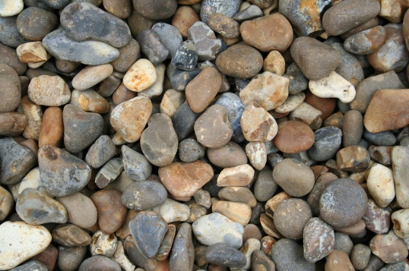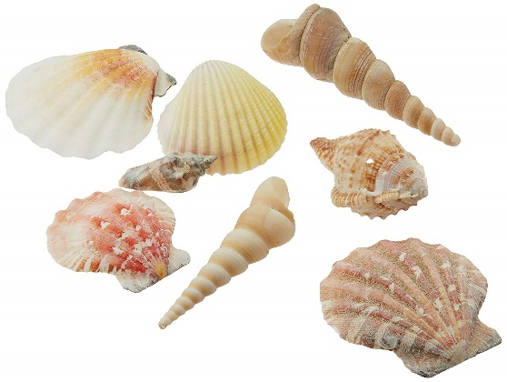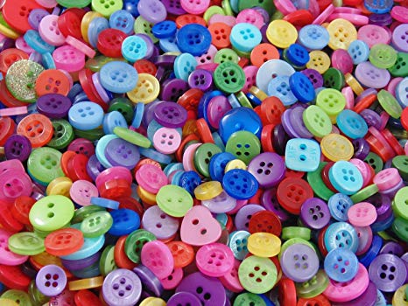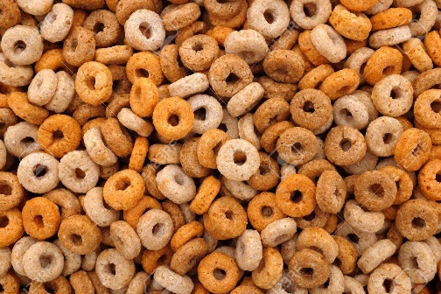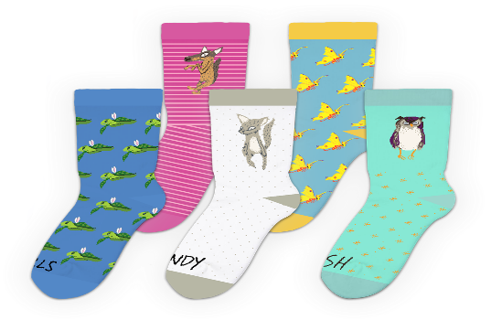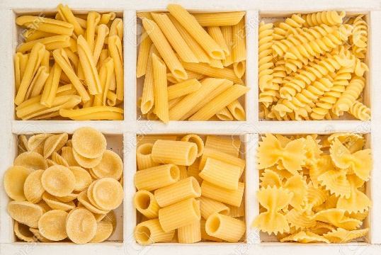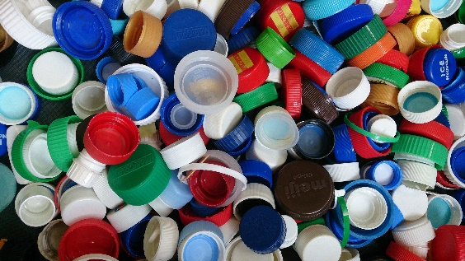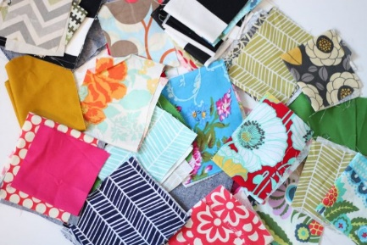

**Useful Resources**

Some of you may be concerned about resources to support your child’s learning at home, particularly for Maths. In school we have lots of open-ended resources which your child will be used to using, alongside more specific resources, such as unifix cubes, number lines and numicon.

You will already have lots of things in and around your home that you can use, without even realizing! Here are some ideas to help.

Stones, pebbles, rocks

shells

buttons

cereals

leaves

socks

pasta

Bottle tops

Fabric scraps