Topic Grid- Complete the science activity and choose some of the other activities to complete this week, have fun!
Story Time - Can you read an animal story to me?  Choose an animal book that you have at home read it aloud and video yourselves then share your video!  Please let me know if you give me permission to post it on the website so your friends to listen too.  I look forward to hearing your wonderful stories.  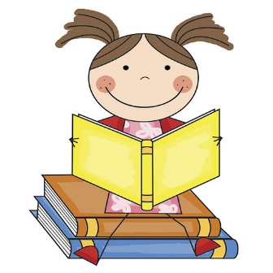 | Science: Habitats  Over the next few week’s we will be learning all about different habitats. Each week you will learn a new one.  I would like you to create a model of each of the habitats, then you can video it and tell me all about the habitat and the facts your have learnt.  What is a polar habitat?  Watch the videos and complete the quiz about Polar habitats.  https://www.bbc.co.uk/bitesize/topics/zx882hv/articles/z3sr4wx  Then using your knew knowledge build your polar habitat model and tell me what you have learnt. Here are some examples of how it may look, don’t forget to include the plants and animals that may live there.  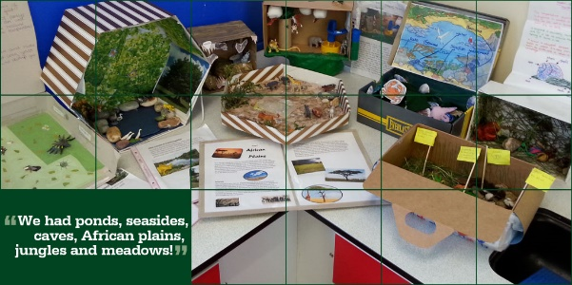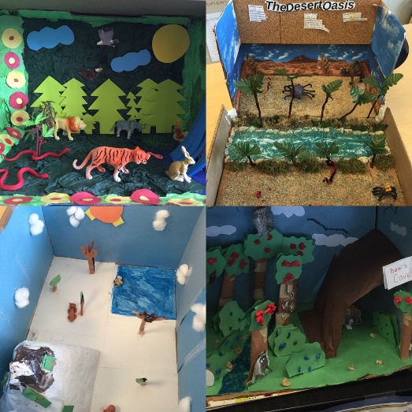
ART- Matisse
Watch the video to learn about Henry Matisse
https://www.youtube.com/watch?v=hy4DUpsC22c

Then follow the instructions in the video to make your own paper collage inspire Matisse art work.
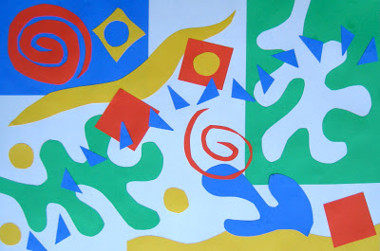
You will need:
Colourful paper
Scissors
Glue
Purple Mash-  Go to your 2dos and complete the Typing Skills activity.  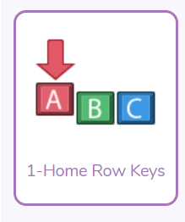 | PE  Yoga  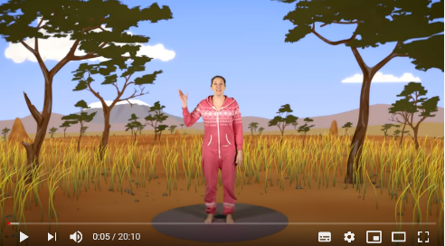 https://www.youtube.com/watch?v=ZvJH8Kbzj54

