How to log in to RM Unify and RMeasimaths
Click on the picture below and open the hyperlink to access the RMunify page for our school
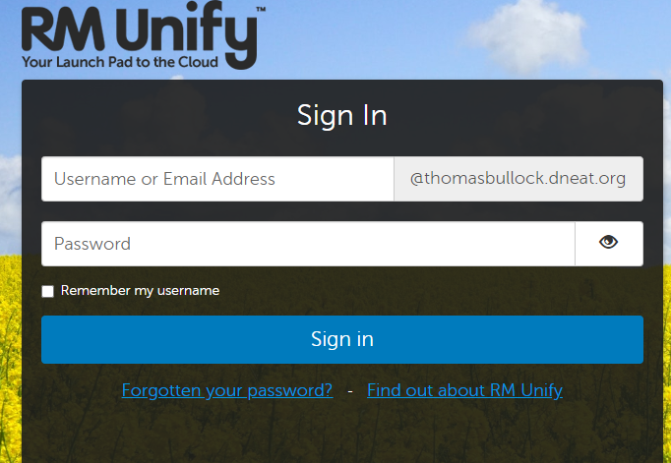

Type in your Username given to you by your school teacher this should be your first initial and last name unless you have been told otherwise by your teacher.
Then type in your password
You may be asked to change your password please change it to the password advised by your teacher.
Once you log in you will be able to see your launch pad
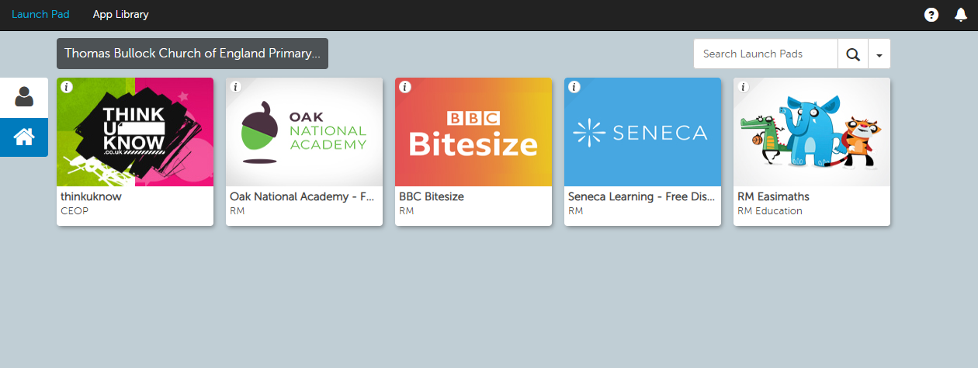

Click on the App that says RM Easimaths this should automatically log you in.

What do you do if adobe flash isn’t working?
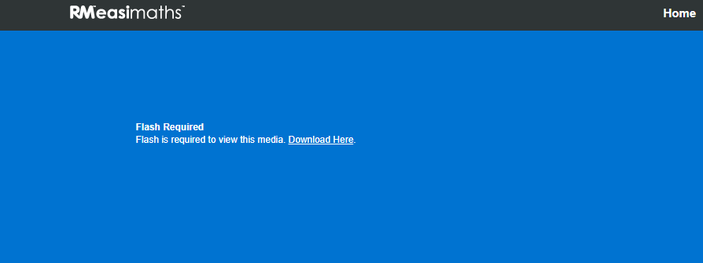
Click on Download here

Click on allow
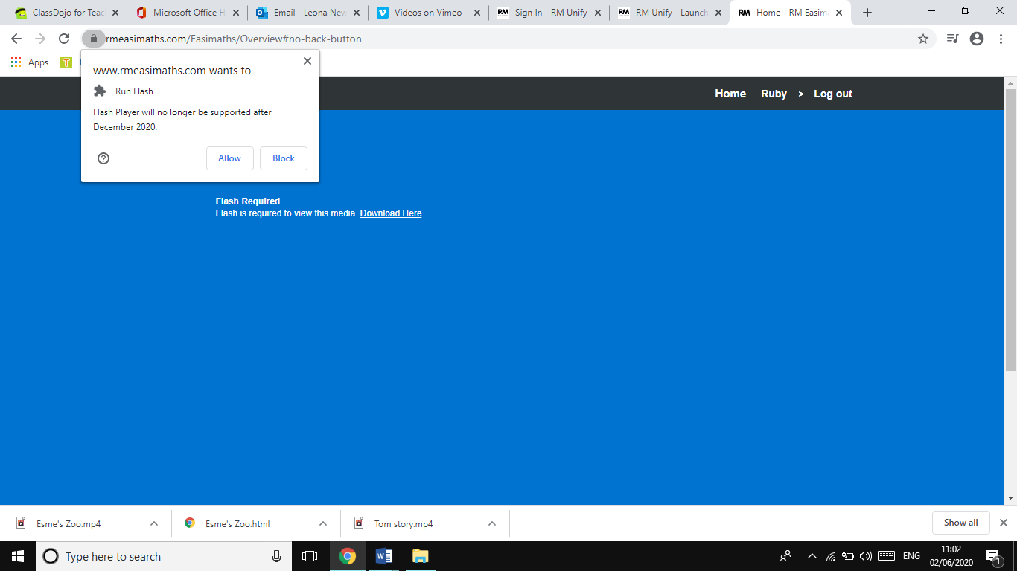
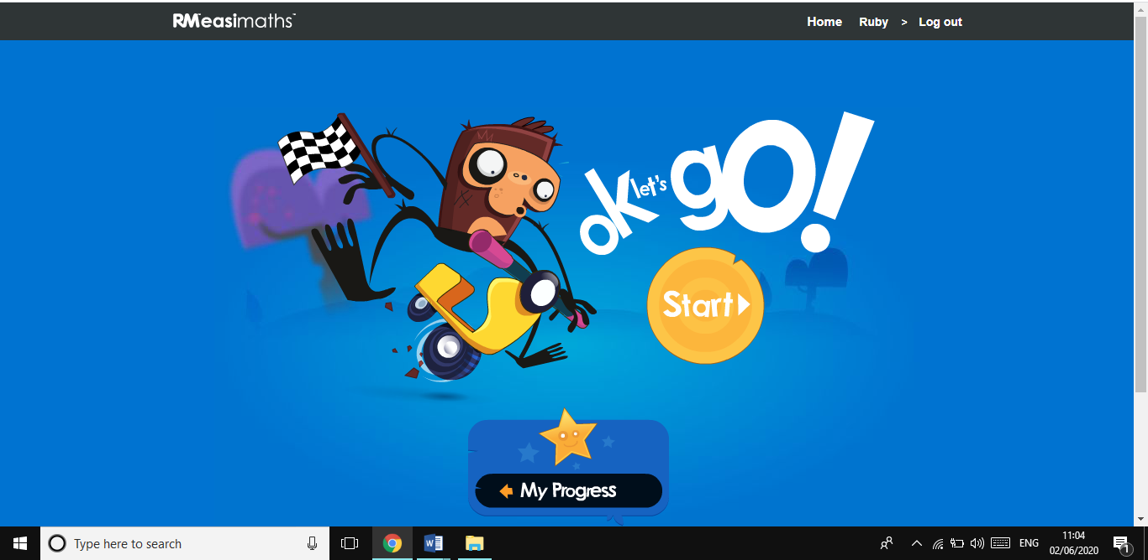
The homepage for RMeasimaths should then load and look like this.

