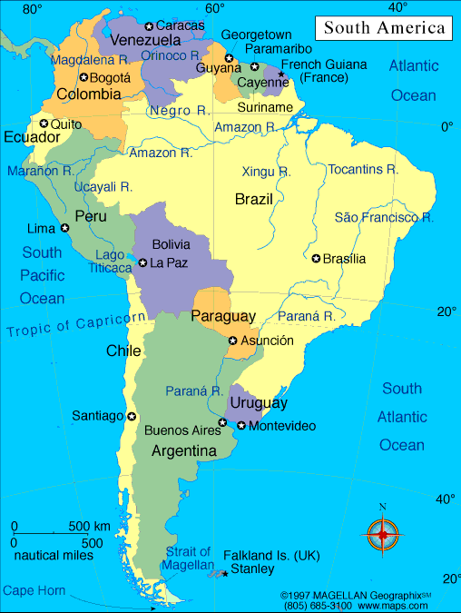**Welcome to South America Class**

**Home Learning research ideas!**

Find South America on a map. Can you find out some facts about South America?

Research the Amazon River – Can you find some fun facts?

Can you create some South American inspired Artwork?

What food do we import from South America?

What animals and habitats are found in the Amazon Rainforest?

Can you find out about Amazonian tribes?

Please feel free to research any areas of South America that interest you!

**Show your findings in any way you like – a piece of art work, a fact-file, in writing – the choice is yours!**

**Please have something ready to show when we return in September – it would be lovely to put your work on the wall and create a display with it!**

Try to read a little every day! You could take part in the summer reading challenge which I have attached too!