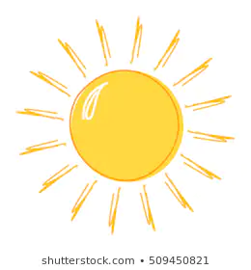
Summer Holiday Task
Year 1 Oceania Class

Over the summer, I would like you to find out five facts about Oceania to be brought in to the first day of school. I do not mind how you wish to present your facts, be creative!

See you in September!

Miss Rayner

