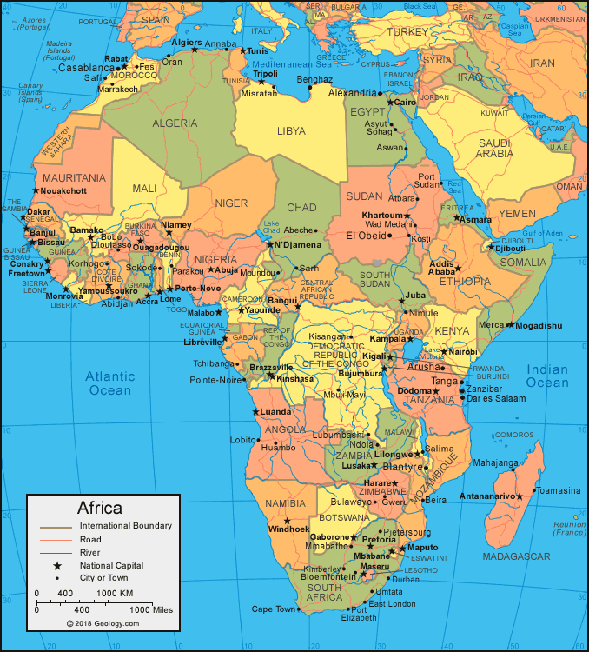Welcome to Africa Class

RM Easimaths is available all through the Summer too if you want to continue practising your maths skills!

Try to read a little every day! You could take part in the summer reading challenge which I have attached too!

**Home Learning research ideas!**

Find Africa on a map. Can you find out some facts about Africa?

Research Nelson Mandela – Who was he and what is he famous for?

Create some African-inspired Artwork

What food do we import from Africa?

What animals and habitats are found in Africa?

Can you find out about African tribes?

Please feel free to research any areas of Africa that interest you!

**Show your findings in any way you like – a piece of art work, a fact-file, in writing – the choice is yours!**

**Please have something ready to show when we return in September – it would be lovely to put your work on the wall and create a display with it!**