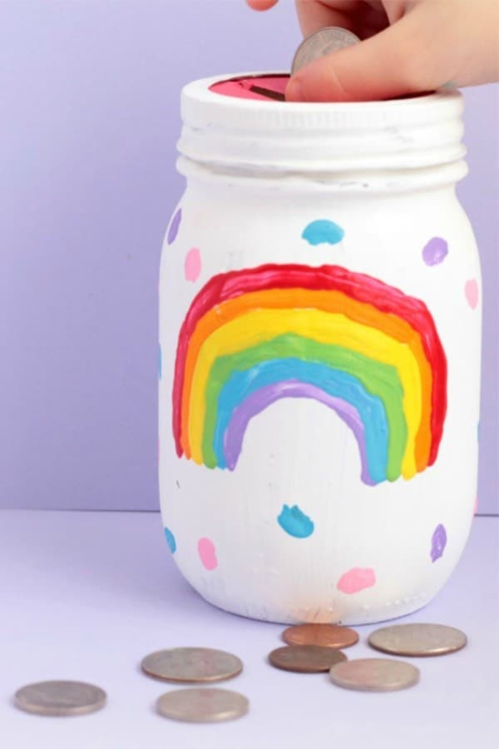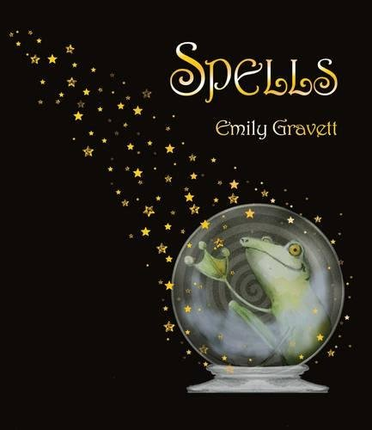

**Science:**

Make some potions! Mix a range of ingredients you can find at home or in the garden and name your creation – what magic can it cause?

Carry out the Coke and Mento experiment to cause your own magical explosion!

It also works with vinegar and baking soda - You can even add food colouring to the vinegar to make it look even more magical!

Watch it here! <https://www.youtube.com/watch?list=UUr35_jUHAosKWCb5KBordJQ&time_continue=8&v=Wh0nJq4A1a8&feature=emb_logo>

**Art:**

Make your own wand!

Look at the document attached for some ideas!

Can you create your own mismatched half and half creatures?

**English:**

KS1: Word match activity

Write your own spell. Can you make it rhyme?

Complete the magical word search.

Can you think of the phrase you might say when you wave your wand?

Write instructions to your own potion. What will it do to people?

Write your own story involving spells!

What wish would you like to make for September? Make a wish jar for it!

**Watch the story here:**

<https://vimeo.com/438628834>

**Maths:**

Measure out the ingredients you need for your potion.

Can all your ingredients total 500ml?