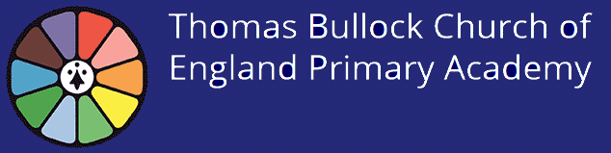
September 2020
Remote Learning Arrangements for Children who are required to self-isolate due to COVID-19
This information is intended as a general guide to our procedures for implementing remote learning from September 2020. There are two scenarios outlined below; the first scenario where your child is not permitted to attend school as they have been advised to self isolate in accordance with government guidelines, the second outlines the actions in case of a whole bubble not being allowed to attend school.
It is a good idea for all parents to ensure that their child can log on to RM Unify and access Google Classroom. now so that should they need to access remote learning they can do this with ease!
The governments Oak Academy online lessons can also be accessed for every year group, covering a wide range of curriculum objectives www.thenationalacademy.co.uk
If you are self-isolating from your bubble in line with government or medical advice due to a member of your household testing positive for COVID-19 and the rest of your class is in school as normal:
- Work will be uploaded to you via Google Classroom by your child’s class teacher. This will mirror the work that is taking place in class. Adults and pupil are responsible to access this work remotely. Tasks and a Google Meet session will take place for children in Early Years and Year 1. In EYFS these may be posted to Tapestry.
- Live and recorded will be provided for Maths and English via Google Meet for Years 2-6.
- A device may be provided, if available, and if you have indicated a need on our technology audit.
- Work may be returned via Google Classroom and this work will be marked by your child’s teacher and feedback given.

If your teacher is self isolating but able to deliver lessons:
- The class will be supervised by a cover teacher or the class teaching assistant and the absent teacher will teach live lessons to the class via Google Meet. Work will be completed in books or uploaded to Google Classroom within school.
If your whole bubble has been asked to self-isolate (but your teacher is well):
- School will provide live learning and pre-recorded sessions each day in line with your class timetable.
- This will be via Google Classroom and Google Meet inside your child’s Google Classroom using your child’s RM Unify account. The live learning will look different depending on the age of the children. The timing of your child’s live learning will be communicated by your child’s teacher via Google Classroom.
- Devices and equipment will be provided for those who have indicated on our audit that they require assistance. Work must be uploaded to Google Classroom and will be marked and feedback given by your child’s teacher in line with our policy.

If your teacher is absent and unable to deliver lessons a cover teacher or teaching assistant will cover the class and work will be provided.

If you are absent for a short period due to illness or whilst awaiting a test result, we will assume you are unwell and therefore work will not be provided.
If your child is self-isolating and normally receives 1:1 support:
Using our Pixl personalised learning checklists a programme of support will be set up which may include phone calls, group or 1:1 video chats with your child’s support adult. This may not be daily and will be in addition to the work provided via Google Classroom.
If the school whole needs to close:
- In all year groups live and pre recorded lessons will be provided via Google Meet and work will be uploaded via your child’s Google Classroom. This will mirror the usual class timetable. For EYFS this will take place via Tapestry.

Please see our parent guides to aid the use of Google Classroom:
http://www.thomasbullock.dneat.org/parent-guides/
Should you have any questions about the work set or your child’s learning, please contact your child’s usual teacher via class dojo during normal school hours.
Should you have any questions about accessing Google Classroom or technological support please contact Mrs. Lowe at homelearning@thomasbullock.dneat.org

