Risk Assessment

Area of assessment: Bubbles Assessment prepared by: Amy Connelly Date: 27.10.2020 Review date: 4.1.2021

Tasks Undertaken  Activity/Area Assessed | Risks | Level of risk  (use  Matrix) |  |  | Control methods | New level  of risk  (use  Matrix)
 |  | L | C | R |  | L | C | R
Bubbles | To prevent the spread of Covid-19 | L | MO | MO | Staff to complete daily bubble registers. Children to remain in their bubbles throughout the session and if need to leave they are to use the 1 metre safe zone in between each bubble. Staff and children to wash hands/use hand sanitizer regularly throughout the session. Social distance to be maintained while in bubbles, to minimise close contact with another person.  Extra cleaning before, after and throughout the sessions, staff to complete the daily cleaning schedule to ensure all cleaning has been completed.  1 member of staff assigned to 1 or 2 bubbles for a whole week to minimise them going between other bubbles.  No soft toys, furnishings to be used. Staff to refrain from touching children’s personal belongings.  Children to take home a name high vis, to bring with them when they attend club. | p | MI | L

Tasks Undertaken  Activity/Area Assessed | Risks | Level of risk  (use  Matrix) |  |  | Control methods | New level  of risk  (use  Matrix)
 |  | L | C | R |  | L | C | R

L: Likelihood (AC, L, P, U, R)
C: Consequence (I, Mi, Mo, Ma, C)
R: Risk level (L, M, H, E)

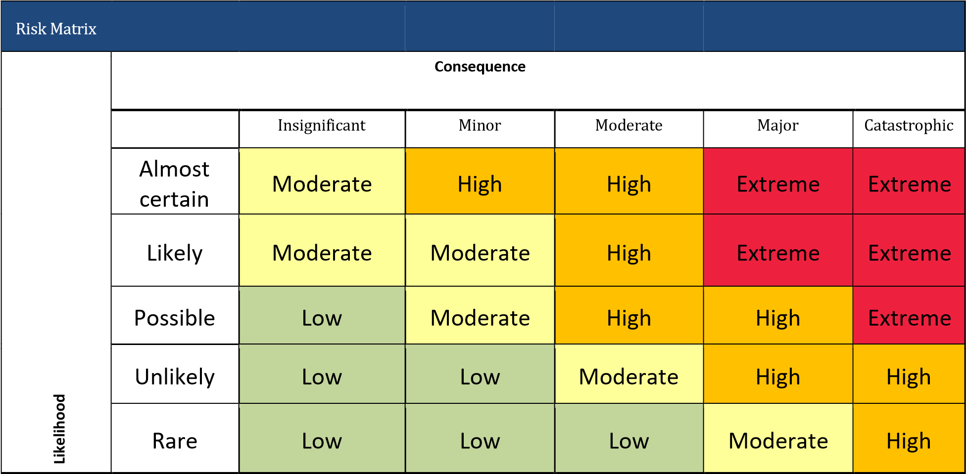

R
Risk Matrix isk Matrix

