Risk Assessment

Area of assessment: Main play space Assessment prepared by: Amy Connelly Date: 27.10.2020 Review date: 4.1.2021

Tasks Undertaken  Activity/Area Assessed | Risks | Level of risk  (use  Matrix) |  |  | Control methods | New level  of risk  (use  Matrix)
 |  | L | C | R |  | L | C | R
Entrance and exit | Children absconding.  Unknown person letting themselves into the building.  Child becoming stuck into the set of double doors. | PO | Ma | HI | Staff to conduct head counts regularly.  Staff to ensure children are aware not to go out of the doors and only to do so if they are with a member of staff.  Staff to challenge any unknown person.  Staff to observe the doorway throughout the session. | un | MI | L
Piano | Children to get injured | PO | MI | MO | Staff to ensure children are aware not to play near or on the piano.  Staff to ensure that the piano is cordoned off from the play space.  Staff to ensure they always have a first aid bag to hand. | un | Mi | L
Club security | Children being taken by an unknown person.  Staff being approached by an unknown person.  Photos being taken of staff and children | Po | MO | HI | Staff to challenge any unknown person/visit and ask them for ID and to sign in on the visitors’ log.  Staff to ensure that any unknown person who cant be ID is to stay outside of the building.  Staff to ensure any visitor on site stores their phones electrical devices in the cupboard/black box and they are told about our No mobile/electrical devices policy. | PO | IN | L
PE equipment | Children injuring themselves  Equipment falling onto someone | PO | MO | HI | Staff not to allow the children on the equipment unless they have been trained.  Staff to make children aware that the equipment is out of bounds | Un | Mi | L

Tasks Undertaken  Activity/Area Assessed | Risks | Level of risk  (use  Matrix) |  |  | Control methods | New level  of risk  (use  Matrix)
 |  | L | C | R |  | L | C | R
Fridge | Food going out of date, leading to food poising.  Contamination | LI | MA | EX | Staff with level 2 food hygiene to ensure food dates are checked daily.  Staff to ensure they are labelling food once opened, with opened date and when to be used by.  Only staff with Level 2 food hygiene to handle food.  If a staff member is feeling unwell not to prepare food.  PPE to be worn when preparing/handling any food.
Toaster | Children burning themselves on the toast | LI | MO | HI | Staff to ensure they are always supervising the children when using the toaster.  Younger children to be supported to use the toaster.  When toaster is not in use to be put away. | LI | MI | MO

L: Likelihood (AC, L, P, U, R)
C: Consequence (I, Mi, Mo, Ma, C)
R: Risk level (L, M, H, E)

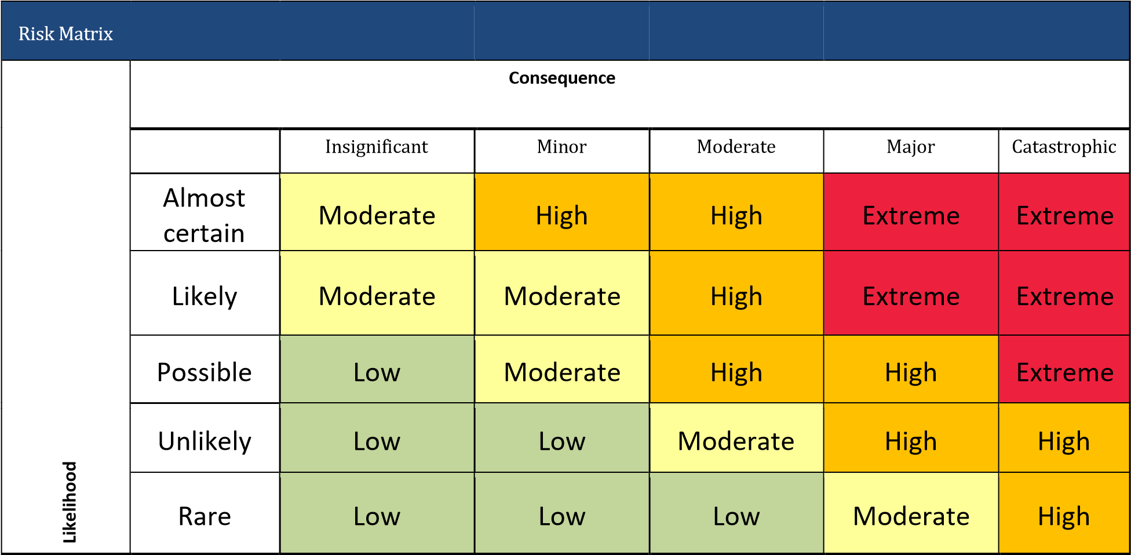

R
Risk Matrix isk Matrix

