Risk Assessment

Area of assessment: Outside play space Assessment prepared by: Amy Connelly Date: 27.10.2020 Review date: 4.1.2021

Tasks Undertaken  Activity/Area Assessed | Risks | Level of risk  (use  Matrix) |  |  |  | Control methods |  | New level  of risk  (use  Matrix)
 |  | L | C | R |  |  |  | L |  | C |  | R
Playground | Slippery surfaces | Li | Mo | HI | Staff to limit time outside if the ground is wet – at staff discretions if they go out or not.  Ensure they are always observing children.  Ensure they have a first aid bag and walkie talkies outside with them.  Talk to the children about what games they can play that are safe when the ground is wet. |  | LI |  | Mi |  | mo
 | Accidents | LI | MO | MO |  | Ensure staff take a first aid bag with them.  Ensure staff have walkie talkies to communicate with staff inside if a child has an accident. |  | LI |  | Mi |  | l

Tasks Undertaken  Activity/Area Assessed | Risks | Level of risk  (use  Matrix) |  |  | Control methods | New level  of risk  (use  Matrix)
 |  | L | C | R |  | L | C | R
 | Club Security | P | MO | HI | Before children are allowed outside, staff need to check for unknown people on the playground and that there are no gates open that have direct access to the playground.  Staff to challenge an unknown people.  Staff to have walkie talkies with them always.  Staff to do regular headcounts | UN | MI | LO
 | Covid | PO | Mo | Hi | When children have access to the outdoor area they need to remain in their bubbles and observe the 2-meter social distancing.  Limit the amount of contact the children have with each other by advising the children of games to play, without physical contact.  Do not let the children share equipment unless it has been wiped down and been left for 10minutes before another person uses it.  Staff to remain at a 2-metre distance from the children. | UN | MI | LO

L: Likelihood (AC, L, P, U, R)
C: Consequence (I, Mi, Mo, Ma, C)
R: Risk level (L, M, H, E)
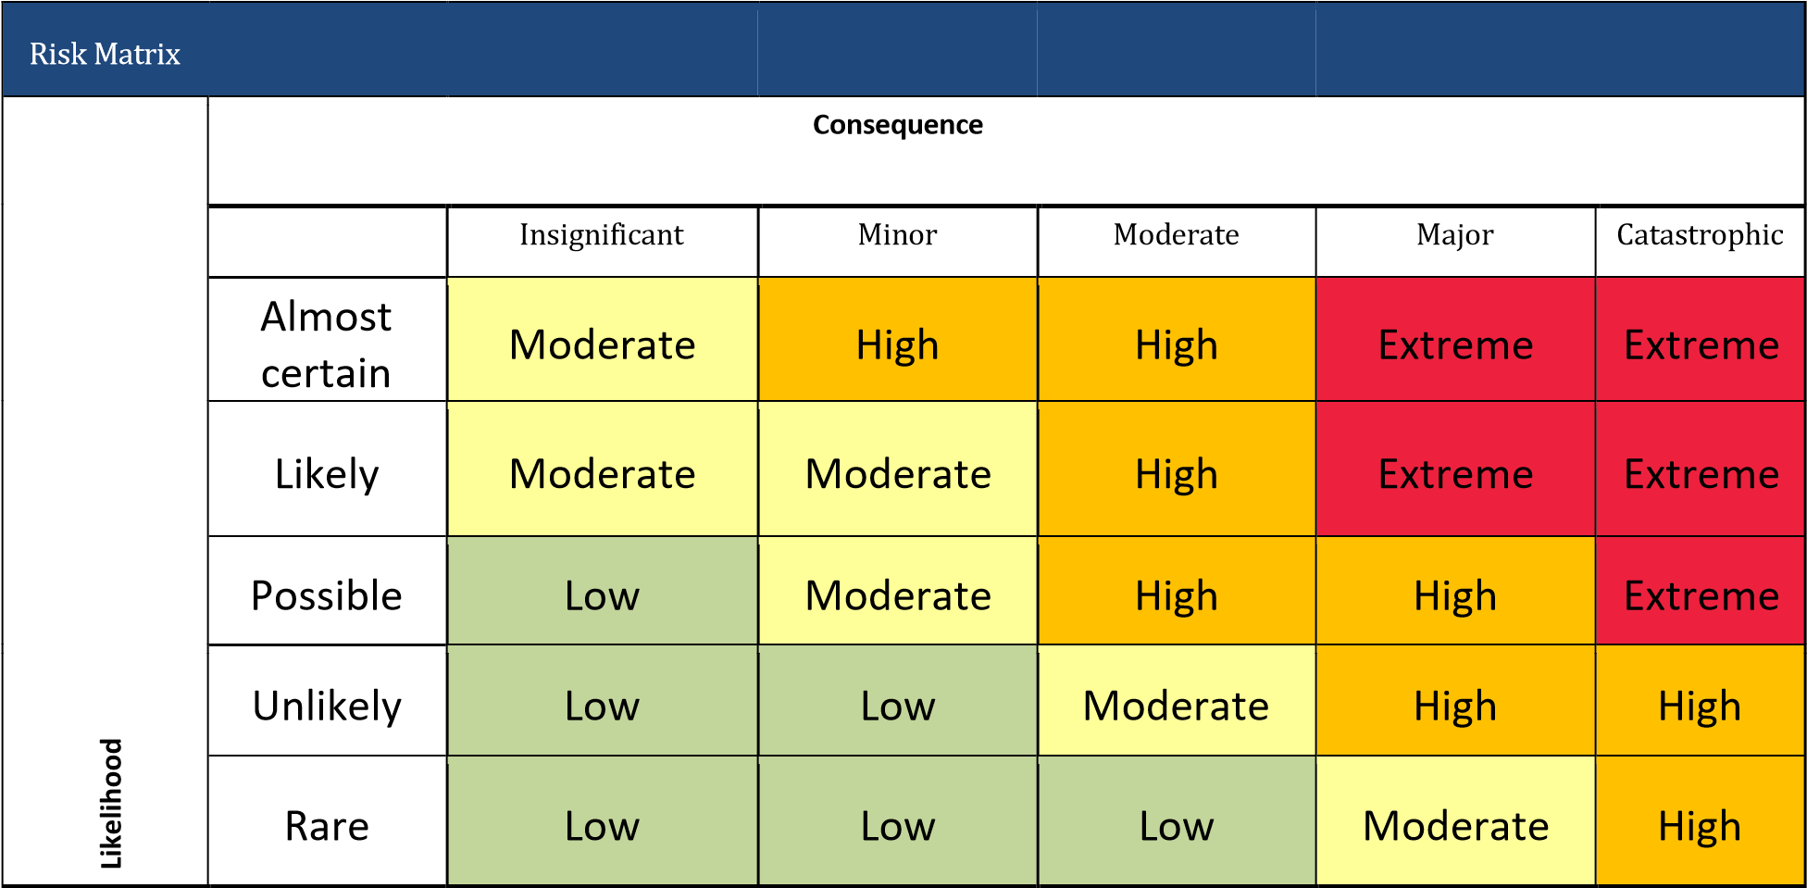

R
Risk Matrix isk Matrix

